1. **Modern History holds significant importance in both the UPSC Prelims and Mains examinations. The syllabus clearly specifies the focus on Mid 18th Century India( ie. from around 1750 onwards), with certain topics explicitly mentioned.  
     
   Mark that Indian National Movement for Freedom Struggle is mentioned explicitly in both papers.**

**Prelims**

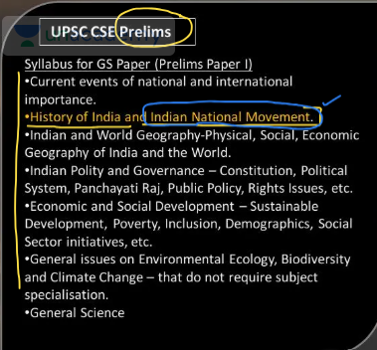

**Mains – Paper 2**

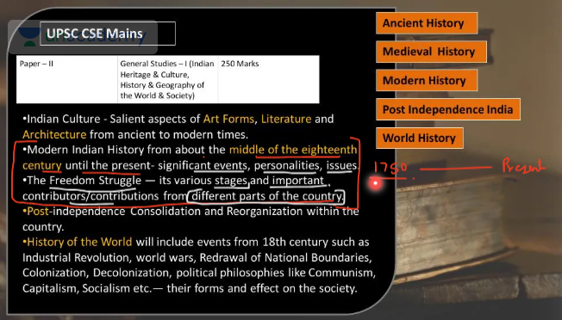

1. **Topics will be covered and their Chronology.**

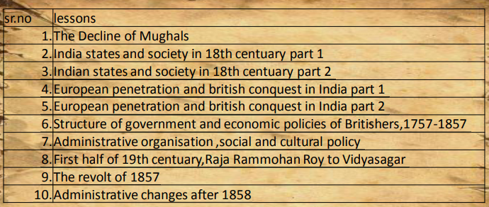

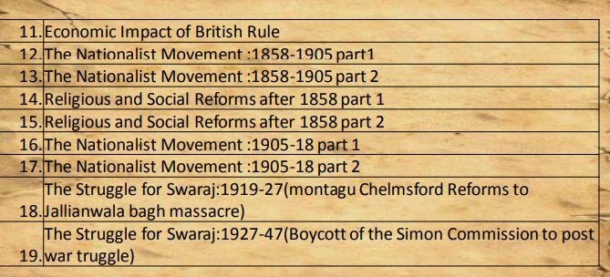

**Chapter 1 : India at the Eve of European Conquests ( Chapter 4 of Spectrum)**

How did the Europeans, who initially came to India as traders, succeed in establishing their rule? What weaknesses within Indian society did they exploit to achieve this?

1. **Understanding Polity, Economy and Society of 18th Century India.**
2. **The Polity of 18th Century India and Its Impact on the Economy and Social fabric Under Different Rulers**
3. **Declining Mughal Polity in 18th Century India: Impact Across the Subcontinent**

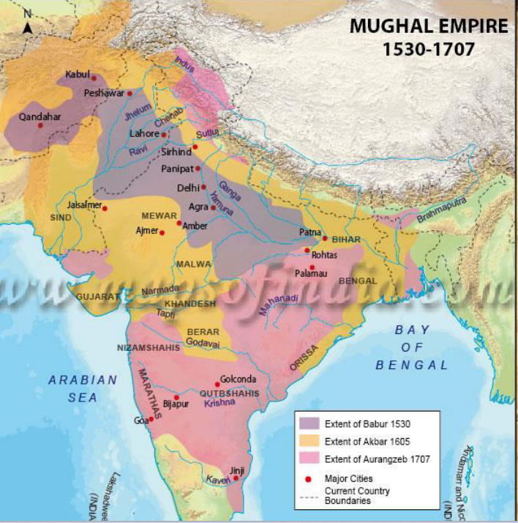

1. **Legacy of Aurangzeb’s Rule (1658 - 1707) and Policies:** Factors Triggering Decline in Central and Wider India

**Great Mughals Terms**

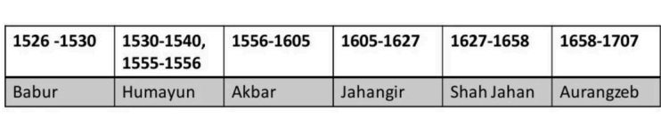

1. **Prolonged and continuous military conflicts**
2. **Intolerant religious policies**
3. **Economic strain inherited from earlier Mughal ruler policies which passed to later Mughals also**

**What is Mansab and Mansabdari?**

* Mansab means *rank or position*.
* It was a military-civil rank system introduced by **Akbar** in the Mughal Empire.
* Every officer (called a Mansabdar) was given a rank that determined:
  + His status in the court
  + Number of soldiers he had to maintain
  + His salary

So, **Mansabdari was the system of assigning ranks (mansabs) and responsibilities to officials.**

**It decrease maintiance overhead from ruler for mainting army.**

**What is Jaagir and Jaagirdari?**

* A Jaagir was a piece of land assigned to a **Mansabdar** instead of a cash salary.
* The Mansabdar would collect revenue (taxes) from that land to pay himself and his soldiers.
* This system was called the **Jaagirdari system**.

So, Jaagirdari was the practice of giving revenue rights of land (jaagir) to officers (mansabdars) in return for military service.

**🔹 Mansabdar ≠ Always Jaagirdar**

* **He could be paid either in cash (naqd) or by granting land (jaagir).**
* **So, only those Mansabdars who were given land revenue rights were called Jaagirdars.**

**🔹 Jaagirdar = Usually a Mansabdar**

* Most Jaagirdars were Mansabdars, because the land (jaagir) was typically given as a part of the Mansabdari system to support their rank and army.
* But in some cases, **land revenue rights could be granted to others (religious scholars, nobles, etc.) who weren’t Mansabdars.**

**📘 Mansabdari & Jaagirdari Crisis – Explained Simply**

| **Aspect** | **Crisis Summary** |
| --- | --- |
| **🔹 Too Many Mansabdars** | More officers were appointed than the system could support as **it was being used by Akbar and other rulers as a gift to make alliance.** |
| **🔹 Shortage of Jaagirs** | Not enough land to grant; **the same land was recycled again and again.** |
| **🔹 Unpaid/Underpaid Officers** | **Mansabdars** received poor-quality land or no land at all. there wasn’t **enough revenue or land** to give them. |
| **🔹 Peasant Exploitation** | Jaagirdars over-taxed peasants to meet revenue needs, causing peasant misery. |
| **🔹 Peasant Revolts** | **Jats, Sikhs, Marathas** revolted due to oppression and over-taxation. |
| **🔹 Corruption & Disloyalty** | Many officials became corrupt or disloyal due to lack of proper rewards. |
| **🔹 Weakening Empire** | The Mughal administration became unstable and lost control over many regions.  **Internal disturbance due to weaking of Army in nutshell.** |

**🧠 Quick Summary for Memory:**

**👉 Too many officers, not enough land  
👉 Officers unhappy → no army maintainance -> weak army -> peasants overtaxed → revolts begin -> internal distrubance  
👉 System breaks down → Mughal decline accelerates - > drain of wealth**

1. **Decline in Leadership Following Aurangzeb’s Death :**

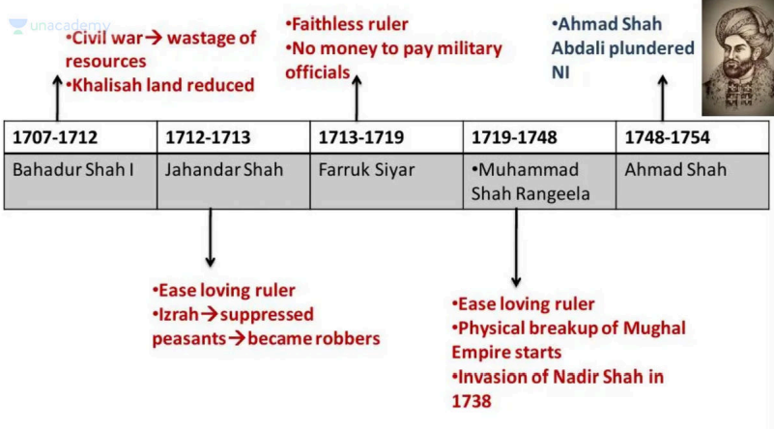

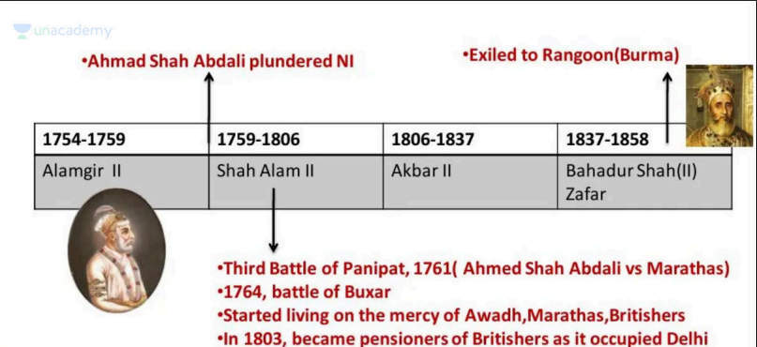

* + 1. **Bahadur Shah I (1707-1712) : (Muazzam)**

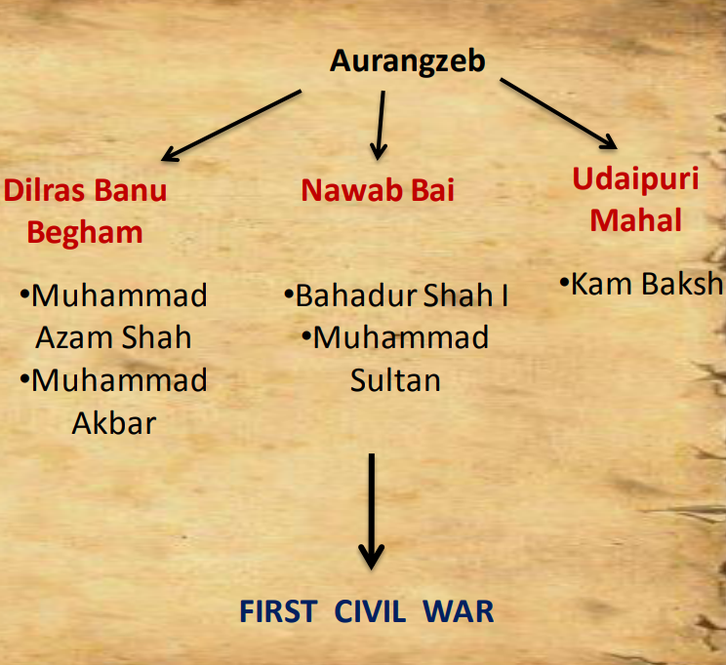

* Became victorious in 1st Civil war following **Aurangzeb’s** **Death** at the age of 65.
* Followed a policy of compromise and conciliation
* Adopted a more tolerant attitude towards the Hindu chiefs and rajas.
* There was no destruction of temples.
* Was Called Shah-e-Bekhabar by **Kafi khan as spent 13 crore in Baharat Darshan.**
* **At least was not a puppet rules like his followers.**

**Tried to Negotiate with :**

* **Rajputs (failed)** : Wanted to replace Jai Singh with Vijay Singh(brother);forced Ajit Singh to submit;wanted to Garrison the cities.

AGREEMENT : **demand of high mansabs and offices of subahdars of Malwa and Gujarat**

no one was happy

states were restored to Rajputs.

* **WITH MARATHA SARDARS (failed)** : Granted **Sardeshmukhi** of Deccan but not **Chauth** which they demanded but he denied and that’s why this also failed.
* **CONCILIATION WITH SIKHS** **(failed)** : Peace with Guru Gobind and Singh and made him his guru but after his death captured his Lohgarh fort.

Rebellion under Banda singh Bahadur who took action in battle of Lohgarh(fort was again revived by Banda Bahadur in 1712).

* **With Jats he got some success :** they established their rule in his term in Bharatpur state (In RAJASTHAN now)

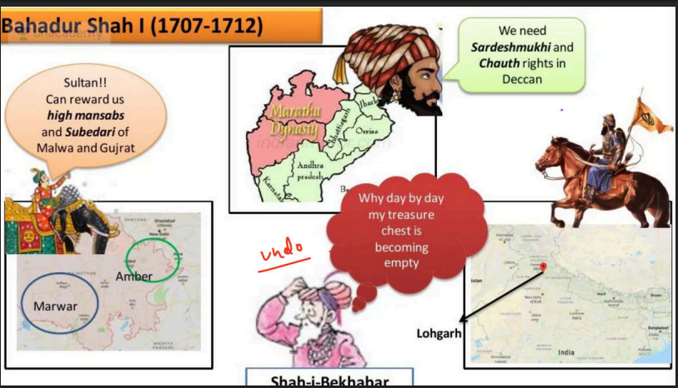

|  |
| --- |
| **✅ What is Subedari? *(Simple Explanation)***   * The Mughal Empire was divided into **provinces** called **Subas**. * Each **Suba** was ruled by a **Subedar** (Governor).   The **Subedari** system refers to the **administrative rule of the Subedar** over a province.  **They are also called Nawabs** |

|  |
| --- |
| **Deccan Under the Mughals:** Events Leading to **Maratha Resistance :**   * + **During Jahangir’s reign**, the Deccan was divided into several weak and independent states.   + **After Vasco da Gama’**s arrival, many European powers entered the Deccan, spreading **Christianity**, often forcefully, and even attacked Hajj-bound ships, creating unrest.   + **Shah Jahan was sent to capture the Deccan**. He first allied with the **warrior class**, who fought wars for money, by ensuring their silence.   + He formed an alliance with Shahji Bhosale (Shivaji’s father) and granted him Pune, which helped him gain a foothold in the region.   + However, Ahmadnagar, under Malik Ambar, remained unconquered during his lifetime.   + After Malik Ambar’s death, his son Fatah Khan handed over Ahmadnagar to Shah Jahan as a gift.   + **Pleased, Shah Jahan re-granted Pune** (earlier promised to the Marathas) to Fatah Khan instead.   + **The Marathas saw this as a betrayal and vowed to weaken Mughal authority**—a legacy carried forward by Shivaji, Shambhaji, and their successors in their persistent struggle against the empire.   **Types of Taxes demanded by Marathas :** Chauth and Sardeshmukhi ?    **Why did the Marathas demand Sardeshmukhi, even when the amount was low? –** Because *Sardeshmukhi* symbolized their claim as the legitimate rulers of the Deccan. More than the money, it served as a token of Mughal acknowledgment of Maratha authority in the region |